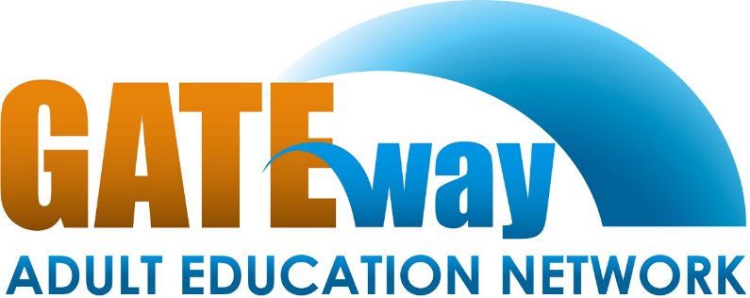
Section 1: Consortium Information
Pathways to
“Getting Adults into Training & Education”

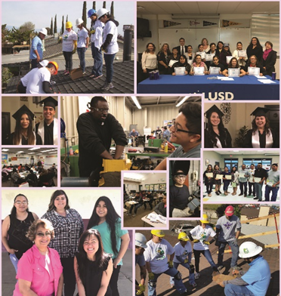
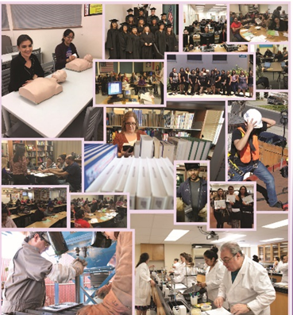
“Adult Education is one of the cornerstones of social investment effort, not only for our own people, but also for people in the community.”
Con Fauconnier

Vilma Reynoso
Consortium Coordinator
(209)325-2810
vreynoso@muhsd.org
mygaen.org

Table of Contents
Section 1: Consortium Information i
Section 2: Comprehensive Regional Three-Year Plan 1
2.1 Executive Summary 1
2.2 Pre-Planning Assessment 2
Table 1. Regional Service Providers 3
Table 3. Funding for Adult Education Programs and Services 6
Gateway Adult Education Network Consortium 6
Table 4. Funding for Adult Education Programs and Services Dos Palos- Oro Loma Joint Unified School District 7
Table 5. Funding for Adult Education Programs and Services 8
Gustine Unified School District 8
Table 6. Funding for Adult Education Programs and Services 9
Le Grand Union High School District 9
Table 7. Funding for Adult Education Programs and Services 10
Los Banos Unified School District 10
Table 8. Funding for Adult Education Programs and Services 11
Mariposa County Unified School District 11
Table 9. Funding for Adult Education Programs and Services 12
Merced Community College District 12
Table 10. Funding for Adult Education Programs and Services 13
Merced County Office of Education 13
Table 11. Funding for Adult Education Programs and Services 14
Merced Union High School District 14
2.3 Community Need and Customers 15
2.4 Identifying Goals and Strategies 20
Figure 5. 20
Table 12. Progress Indicators 23
2.5 Piloting and Implementation 24

Section 2: Comprehensive Regional Three-Year Plan

2.1 Executive Summary
The Gateway Adult Education Network Consortium (GAEN) is one of the 71 adult education consortia in the state of California. The GAEN region consists of a large, but lightly populated area in the San Joaquin Valley and includes Chowchilla (Northern Madera Co.), Mariposa, and Merced counties; an area of mountainous, agricultural, semi-urban, urban and rural communities. Such a diverse area provides opportunities for adult education expansion, but also raises challenges that such a diverse territory encompasses. GAEN regional demographics show that more than 55, 000 out of 206, 907 adults do not possess a high school diploma or equivalent Merced Community College, Merced County Office of Education and the six school districts in the region will continue to assist hundreds of people to become educated and trained people through the efforts of the Network entering 2020. GAEN top priorities are continuing and restoring basic education services after many were eliminated during flexibility, including English-as-a-Second Language, Adult Basic Education, High School Diploma and Equivalency (GED).
In order to address the needs of the students within the region, GAEN has created a three-year plan to improve adult education services beyond the year 2020. GAEN has selected goals to focus its efforts on maintaining an effective collaborative process, enhancing successful transitions to college and career for students and better serving students with disabilities. This three-year plan also involves the implementation of new strategies, such as adding an Individual Learning Plan that will be used across the region, increasing workforce and career services, and strengthening partnerships with local and regional agencies to increase student success.
Realistically, for the next three years, most of the districts in this consortium will be working to continue developing lasting programs to meet the needs of adult learners.

2.2 Pre-Planning Assessment
Gateway Adult Education Network Consortium (GAEN) pre-planning process began fall 2018 with the GAEN Needs Assessment. GAEN members, community partners, students and the community as a whole were surveyed and which helped GAEN members start the goal setting process. Each GAEN member completed the Self-Assessment provided by CAEP. All eight members participated in a Self-Assessment session and they carefully analyzed the needs of the region, their individual communities, adult learners, faculty, staff and other stakeholders.
GAEN Needs Assessment
Click the picture to read the full assessment

GAEN Program Quality Self-Assessment
Click the picture to read the full assessment

Table 1. Regional Service Providers
Provider Name | Provider Type | Address or location(s) where AE services are provided | Program Areas
 |  |  | ABE | ASE | ESL | CTE | AWD | WR | PA | ACS
Dos Palos Oro Loma Joint Unified School District | School District | 22368 South 6th St. South Dos Palos CA 93665
Gustine Unified School District | School District | 685 Wallis Ave. Gustine CA 95322
Le Grand Union High School District | School District | 12961 Le Grand Rd, Le Grand CA 95333
Los Banos Unified School District | School District | 1717 South 11th St. Los Banos CA 95635
Mariposa County Unified School District | School District | 5082 Old Highway North Mariposa CA 94338
Merced Community College District | Community College | 630 West 19 St. Merced CA 95340
Merced County Office of Education | County Office of Ed. | 732 West 13th St. Merced CA 95340 |  |  |  |  |  |  | X
Merced Union High School District | School District | 50 East 20th St. Merced CA 95340

Table 2: List of Adult Education Providers and Program Offerings

Member | Area of Service | Program Offerings
Dos Palos- Oro Loma  Joint Unified  School District | Dos Palos  South Dos Palos  Oro Loma | Adult Basic Education/Adult Secondary Education  High School Diploma  ESL  Citizenship
Gustine Unified  School District | Gustine  Santa Nella  Stevinson | Adult Basic Education/Adult Secondary Education  High School Diploma  ESL
Le Grand Union  High School District | Le Grand  Plainsburg  Planada | Citizenship  ESL  GED Preparation  High School Diploma  CTE Beginning Welding
Los Banos Unified School District | Los Banos | High School Diploma  GED
Mariposa County  Unified School District | Mariposa  El Portal | High School Diploma  ESL
Merced County Office of Education | Atwater  Los Banos  Merced | CTE  Foundations in Early Education  Marketing and Customer Service  Construction Technology | Automotive Technology  Logistics and Warehousing  Culinary Experience
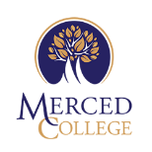  Merced Community College District | Atwater  Chowchilla  Delhi  Livingston  Merced  Planada  Winton  Los Banos | College Pre/Math I, II. II, IV  ESL  Career & Life Planning  Intro to Microcomputers  Microcomputers & Business  Basic Skills and GED Preparation  Medical Assisting | Bus Driver Training  College Prep English 1 Reading  College Prep English 2 Writing  Citizenship Preparation  Introduction to Microcomputers and Basic Computers Applications  Daily Livings Skills  Reading and Computers I & II
Merced Union High School District | Atwater  Livingston  Merced  Winton | ESL  VSEL  Conversation Café  Citizenship Preparation  ABE/AES  High School Diploma  GED Preparation  Family Literacy  Medical Administrative Assistant  Introduction to Office Administrative Assistant | Computer Fundamentals/IC3 Certification  Google Basics  Green Technology & Energy Conservation  CPR/First Aid  Serve Safe Certification/ Workplace Safety  Computerized Office Technology  Career Foundations  Clerical/Microsoft Office Specialist (MOS)

Table 3. Funding for Adult Education Programs and Services

Gateway Adult Education Network Consortium
Source and Type of Funds | Funding Estimates FY2019-20 | Funding Estimates FY2020-21 | Funding Estimates FY2021-22
State / Federal Funding
AEP | $3,385,649 | $3,385,649 | $3,385,649
CalWORKs | $341,194 | $341,194 | $341,194
CCD Apportionment | $247,631 | $247,631 | $247,631
Corrections | $0 | $0 | $0
LCFF / District Funds | $1,173,006 | $1,301,654 | $1,363,236
Perkins V | $0 | $0 | $0
WIOA II | $180,000 | $180,000 | $180,000
Other | $0 | $0 | $0
State and Federal Grants | $999,439 | $999,439 | $999,439
In-kind | $1,927,660 | $1,927,660 | $1,927,660
 | $0 | $0 | $0
 | $0 | $0 | $0
 | $0 | $0 | $0
 | $0 | $0 | $0
Total | $8,254,579 | $8,254,579 | $8,254,579

Table 4. Funding for Adult Education Programs and Services Dos Palos- Oro Loma Joint Unified School District

Source and Type of Funds | Funding Estimates FY2019-20 | Funding Estimates FY2020-21 | Funding Estimates FY2021-22
State / Federal Funding
AEP | $80,056 | $80,056 | $80,056
CalWORKs | $0 | $0 | $0
CCD Apportionment | $0 | $0 | $0
Corrections | $0 | $0 | $0
LCFF / District Funds | $0 | $0 | $0
Perkins V | $0 | $0 | $0
WIOA II | $0 | $0 | $0
Other | $0 | $0 | $0
 | $0 | $0 | $0
Total | $80,056 | $80,056 | $80,056

Table 5. Funding for Adult Education Programs and Services

Gustine Unified School District

Source and Type of Funds | Funding Estimates FY2019-20 | Funding Estimates FY2020-21 | Funding Estimates FY2021-22
State / Federal Funding
AEP | $187,646 | $187,646 | $187,646
CalWORKs | $0 | $0 | $0
CCD Apportionment | $0 | $0 | $0
Corrections | $0 | $0 | $0
LCFF / District Funds | $70,000 | $70,000 | $70,000
Perkins V | $0 | $0 | $0
WIOA II | $5,000 | $5,000 | $5,000
Other | $0 | $0 | $0
In-Kind | $215,994 | $215,994 | $215,994
Total | $478,640 | $478,640 | $478,640

Table 6. Funding for Adult Education Programs and Services

Le Grand Union High School District
Source and Type of Funds | Funding Estimates FY2019-20 | Funding Estimates FY2020-21 | Funding Estimates FY2021-22
State / Federal Funding
AEP | $78,573 | $78,573 | $78,573
CalWORKs | $0 | $0 | $0
CCD Apportionment | $0 | $0 | $0
Corrections | $0 | $0 | $0
LCFF / District Funds | $0 | $0 | $0
Perkins V | $0 | $0 | $0
WIOA II | $0 | $0 | $0
Other | $0 | $0 | $0
 | $0 | $0 | $0
Total | $78,573 | $78,573 | $78,573

Table 7. Funding for Adult Education Programs and Services

Los Banos Unified School District
Source and Type of Funds | Funding Estimates FY2019-20 | Funding Estimates FY2020-21 | Funding Estimates FY2021-22
State / Federal Funding
AEP | $41,769 | $41,769 | $41,769
CalWORKs | $0 | $0 | $0
CCD Apportionment | $0 | $0 | $0
Corrections | $0 | $0 | $0
LCFF / District Funds | $0 | $0 | $0
Perkins V | $0 | $0 | $0
WIOA II | $0 | $0 | $0
Other | $0 | $0 | $0
 | $0 | $0 | $0
Total | $41,850 | $41,850 | $41,850

Table 8. Funding for Adult Education Programs and Services

Mariposa County Unified School District

Source and Type of Funds | Funding Estimates FY2019-20 | Funding Estimates FY2020-21 | Funding Estimates FY2021-22
State / Federal Funding
AEP | $197,040 | $197,040 | $197,040
CalWORKs | $0 | $0 | $0
CCD Apportionment | $0 | $0 | $0
Corrections | $0 | $0 | $0
LCFF / District Funds | $0 | $0 | $0
Perkins V | $0 | $0 | $0
WIOA II | $0 | $0 | $0
Other | $0 | $0 | $0
 | $0 | $0 | $0
Total | $197,040 | $197,040 | $197,040

Table 9. Funding for Adult Education Programs and Services

Merced Community College District

Source and Type of Funds | Funding Estimates FY2019-20 | Funding Estimates FY2020-21 | Funding Estimates FY2021-22
State / Federal Funding
AEP | $614,470 | $614,470 | $614,470
CalWORKs | $0 | $0 | $0
CCD Apportionment | $247,631 | $247,631 | $247,631
Corrections | $0 | $0 | $0
LCFF / District Funds | $1,173,006 | $1,231,657 | $1,293,239
Perkins V | $0 | $0 | $0
WIOA II | $0 | $0 | $0
Other | $0 | $0 | $0
In-Kind | $1,288,306 | $1,288,306 | $1,288,306
Total | $3,323,413 | $3,382,064 | $3,443,646

Table 10. Funding for Adult Education Programs and Services

Merced County Office of Education

Source and Type of Funds | Funding Estimates FY2019-20 | Funding Estimates FY2020-21 | Funding Estimates FY2021-22
State / Federal Funding
AEP | $251,707 | $251,707 | $251,707
CalWORKs | $0 | $0 | $0
CCD Apportionment | $0 | $0 | $0
Corrections | $0 | $0 | $0
LCFF / District Funds | $0 | $0 | $0
Perkins V | $0 | $0 | $0
WIOA II | $0 | $0 | $0
Other | $0 | $0 | $0
Other State Grants | $999,439 | $999,439 | $999,439
In-kind | $423,360 | $423,360 | $423,360
Total | $1,674,506 | $1,674,506 | $1,674,506

Table 11. Funding for Adult Education Programs and Services

Merced Union High School District
Source and Type of Funds | Funding Estimates FY2019-20 | Funding Estimates FY2020-21 | Funding Estimates FY2021-22
State / Federal Funding
AEP | $1,930,081 | $1,930,081 | $1,930,081
CalWORKs | $341,194 | $341,194 | $341,194
CCD Apportionment | $0 | $0 | $0
Corrections | $0 | $0 | $0
LCFF / District Funds | $0 | $0 | $0
Perkins V | $0 | $0 | $0
WIOA II | $175,000 | $175,000 | $175,000
Other | $0 | $0 | $0
 | $0 | $0 | $0
 | $0 | $0 | $0
Total | $2,446,275 | $2, 446,275 | $2, 446,275

2.3 Community Need and Customers
Gateway Adult Education Consortium conducted a Needs Assessment by an independent consultant. A copy of the complete assessment will be attached to the 3 Year Plan. Below is the Executive Summary.
GAEN Needs Assessment
EXECUTIVE SUMMARY
The purpose of this document is to paint a current and accurate picture of the Adult Education System within the region served by the Gateway Adult Education Network (GAEN). In order to best serve its current students and attract new students, GAEN must be able to recognize and quantify its strengths and opportunities. As GAEN embarks on the development of its next 3-Year Plan (2019-2022), it was agreed by the GAEN Board that a comprehensive needs assessment should be undertaken in order to inform the Plan and to ensure that any future actions are directly responsive to community needs. The process of conducting the assessment took place between May 2018 and December 2018. During that time period, 27 individuals were interviewed (some on multiple occasions) and 395 individuals were surveyed. In tandem with the survey/interview process, a review of demographic information, existing literature, and best practices were undertaken. The resulting document includes suggestions for action that the consortium can take, both in the short and long-term, to address the gaps identified herein.
GAEN Need Assessment
Click the picture to read the full assessment

Figure 1: Regional Demographics
Gateway Adult Education Network Consortium evaluated the regional demographics and compared to the current students to decide what specifics populations should be observant during the next three years. Please see the figure below.
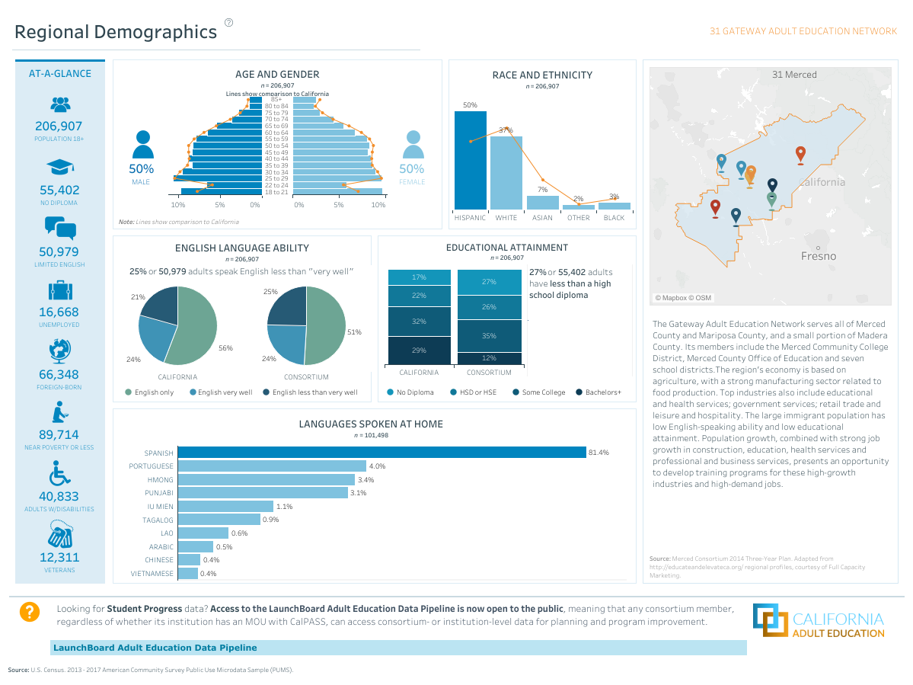
Source: U.S. Census 2013-2017. American Community Survey Public Use Microdata Sample (PUMS)
***More information about California Adult Education Consortia please visit Caladulted/FactSheets.***

Figure 2: Labor Market Outlook by Industry

Source: U.S. Census 2013-2017. American Community Survey Public Use Microdata Sample (PUMS)
***More information about California Adult Education Consortia please visit Caladulted/FactSheets.***

Figure 3. Top Occupations and Top 10 Fastest Growing Occupations

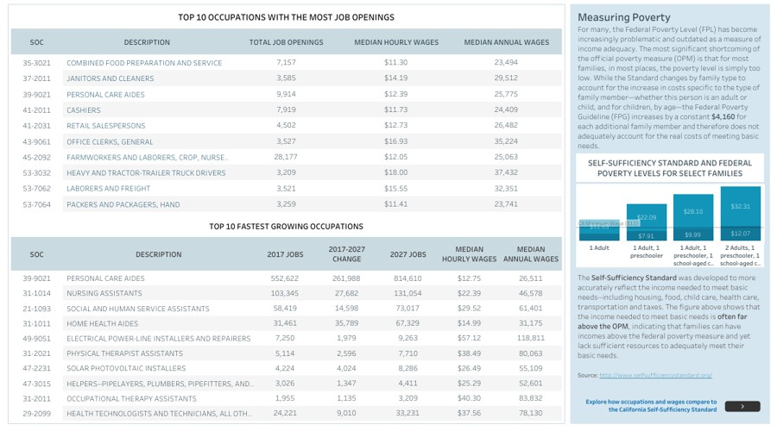
Source: Center for Women's Welfare, University of Washington. For more information, see http://www.selfsufficiencystandard.org/california
***More information about California Adult Education Consortia please visit Caladulted/FactSheets.***

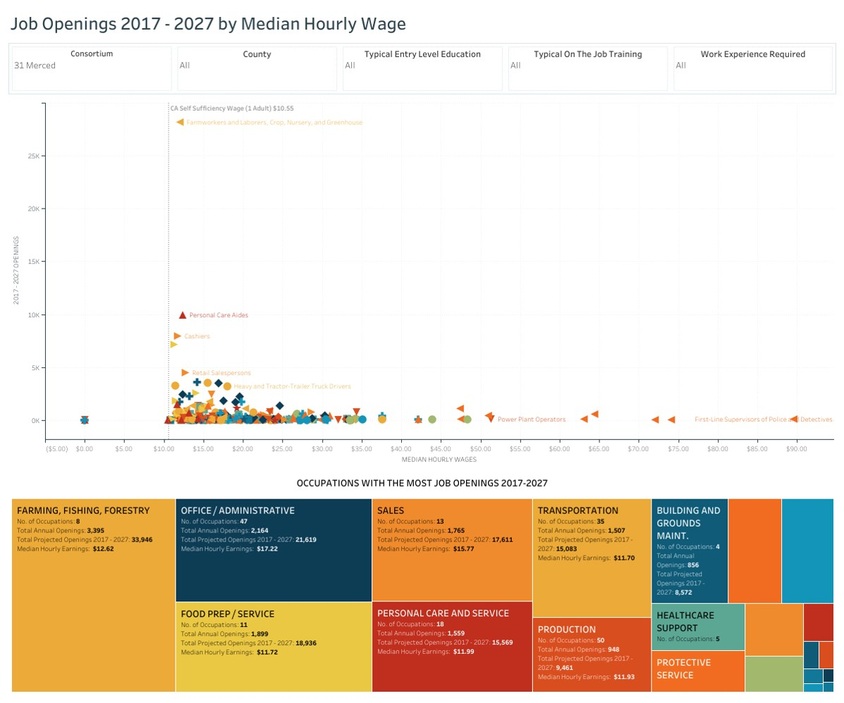
Figure 4. Job Openings 2017-2027
***Data sources: U.S. Bureau of Labor Statistics' Current Employment Statistics and Quarterly Census of Employment and Wages. ***
***More information about California Adult Education Consortia please visit Caladulted/FactSheets.***

2.4 Identifying Goals and Strategies

Figure 5.
Goal Statement: 1. Consortium to maintain an effective collaborative process for planning, implementing and accountability.
Inputs | Activities | Outputs | Immediate (Short-Term) Outcomes | Intermediate Outcomes | Long-Term Outcomes / Impact
- All Consortium members understand their role as a Board member; thoroughly read and understand the Needs Assessment document; lead us to understand the main purpose of the consortium. | - Environmental Scan of what is being offered and what is being spent by whom including as much as we know about the community resources outside GAEN.  - Using the Needs Assessment as a resource to evaluate programs being offered, gaps in services and potential solutions.  - Ensure that all spending is promoting the Seven Elements of Quality Adult Education. | - New Proposal for Funding Template that details program specifics and what the money is being spent and on which of the seven categories.  - Community Advisory Committee to address what is currently being done by the consortium and get feedback on what is still needed. | - Better address gaps in service in order to generate an appropriate program plan | - Yearly program plans will address need gaps in our region. | - All programs show growth or will be re-evaluated.

Goal Statement: 2. Consortium students to complete an individualized learning plan that reflects an informed understanding of the educational and career options.
Inputs | Activities | Outputs | Immediate (Short-Term) Outcomes | Intermediate Outcomes | Long-Term Outcomes / Impact
- GAEN consortium members need to have an Individualized Learning Plan(ILP) to be used region-wide. | - GAEN members will identify areas to be addressed on the individualized learning plan. | - GAEN students will have a detailed plan of how to accomplish their goals, as stated in the ILP. | - GAEN members will use the ILP will all the “new” incoming students. | - Each Adult Learner will have a defined ILP which can be used as the students transition to another adult school, community college or work. | - Adult Learner will be meeting the goals established in their ILP.

Goal Statement: 3. Consortium members to provide educational and career services for Adults with Disabilities.
Inputs | Activities | Outputs | Immediate (Short-Term) Outcomes | Intermediate Outcomes | Long-Term Outcomes / Impact
- GAEN consortium members need to have an individualized learning plan to be used region-wide. | - Align ABE courses across the consortium to develop a program of study for adults with disabilities  - Develop a CTE culinary program to serve mid to moderated adults with disabilities. | - GAEN students eligible for the program will be identified and they will receive the counseling and guidance needed to get the students enrolled in the program.  - Community Agencies will have a program of study that they can use to refer to students. | - Course offerings in place for Aw/D that provide them with employable skills needed by the local job market.  - Summer short-term culinary course (6-weeks) started for approximately 12 students | - Be able to run a culinary course year-round, increasing the number of students served.  - Bring on several industry partners that will employ students for internships.  - Work with community agencies to add paid internships to the program. | - Increased number of the Consortium’s Aw/D program completers that are gainfully employed in the local job market.  - Culinary programs can grow to other communities by either working with Wired Café’s extended locations or finding other partners.  - Employ adults with disabilities through the ABE and CTE POS.

Goal Statement: 4. Consortium members to have aligned and articulated programs.
Inputs | Activities | Outputs | Immediate (Short-Term) Outcomes | Intermediate Outcomes | Long-Term Outcomes / Impact
- MAS continues the discussion with MCCD on articulation with Computer and Office Technology class and Administrative Office Management program.  - MCCD VPI, Director of Adult Education & Noncredit, MAS Superintendent, faculty input, student feedback. | - Develop an articulation agreement between MAS and MCCD.  - MCCD: Administrative meeting to discuss next steps; meeting to discuss changes with faculty & obtain feedback. | - MAS students can receive MCC credits when completing articulated courses.  - MCCD: Articulation agreement between MCCD & MAS | - MAS students can receive MCCD credits when completing articulated courses.  - MCCD: Improved services for students; partnership among discipline faculty | - Students in MAS’s Computer and Technology class will transition to MCCD’s AOM program.  - MCCD: Increase in the number of feeder students from MAS | - Students in MAS’s Computer and Technology class will transition to MCCD’s AOM program.  - MCCD: Data collection that shows higher student numbers.

Table 12. Progress Indicators

- By November 2019 an Advisory committee will be created to provide input on the programs being offered, gaps in services and potential solutions.
- By December 2019 a consortium-wide Individualized Learning Plan and Program of Study will be created to ensure successful transitions to college and career for adult learners.
- By June 2020 we will have an educational and career program for adult learners with disabilities.
- By June 2022 we will have in place an articulation agreement with Merced Community College District that includes multiple career pathway opportunities.

2.5 Piloting and Implementation

GAEN has selected new strategies to be implemented in order to close any gaps and meet the needs of our students and potential students in our region.

- GAEN consortium plans to work on recruiting more community partners, industry and educational agencies. These partners will be part of the Advisory Committee that will be meeting at least once per year. During the Advisory Meetings, the partners will have the opportunity to provide input on the programs being offered, gaps in services and provide potential solutions.
- GAEN Consortium plans to work on completing an Individualized Learning Plan and Program of Study for every student within the region. This ILP/POS will shows aligned and articulated work and the transition from course to course, program to program and to post-secondary or the workforce.
- GAEN consortium will be working directly with Merced County Special Education Department, Central Valley Regional Center, Department of Rehabilitation, and other agencies that provide services to Adults with Disabilities to create an educational and career program for Adults with Disabilities. This program is specializing in helping adults with disabilities to learn the necessary skills to work in the Food Industry. The students will learn hands-on customer services, point of sales experience, food preparation, opening and closing procedures, catering, inventory, and other skills that will help the students get a job in the Food Industry.

